1. AWT
2. Swing
3. JAVA fx

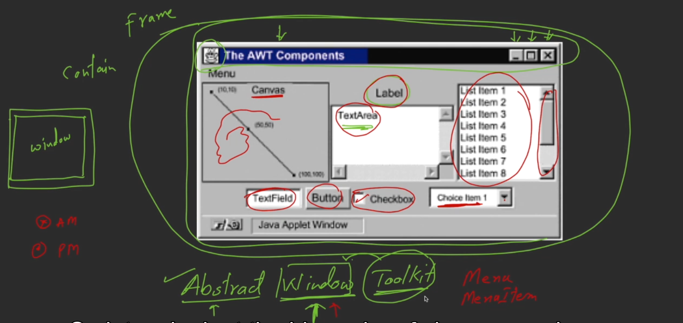

Frame is the container of other components

Green 🡪 frame  
Red 🡪 container

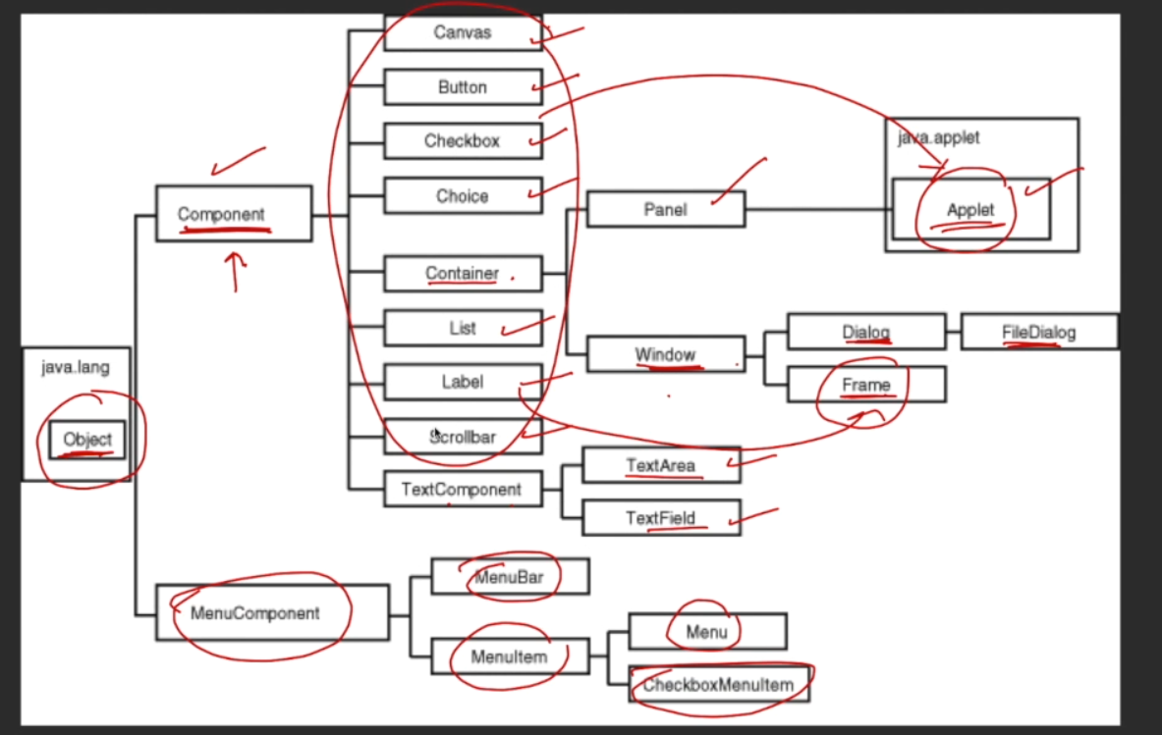

Object class is the mother for all classes in java.

Frame 🡪 used for developing applications that run on the desktop.  
Applets 🡪 used for developing applications that runs inside the browser.

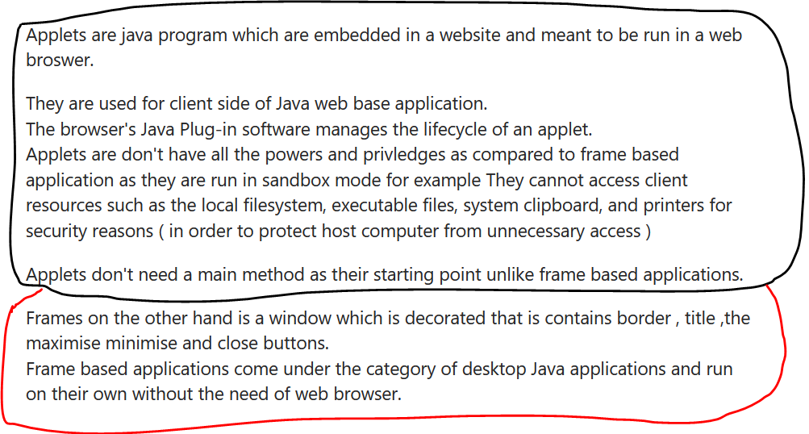

## Refer basic_1.java

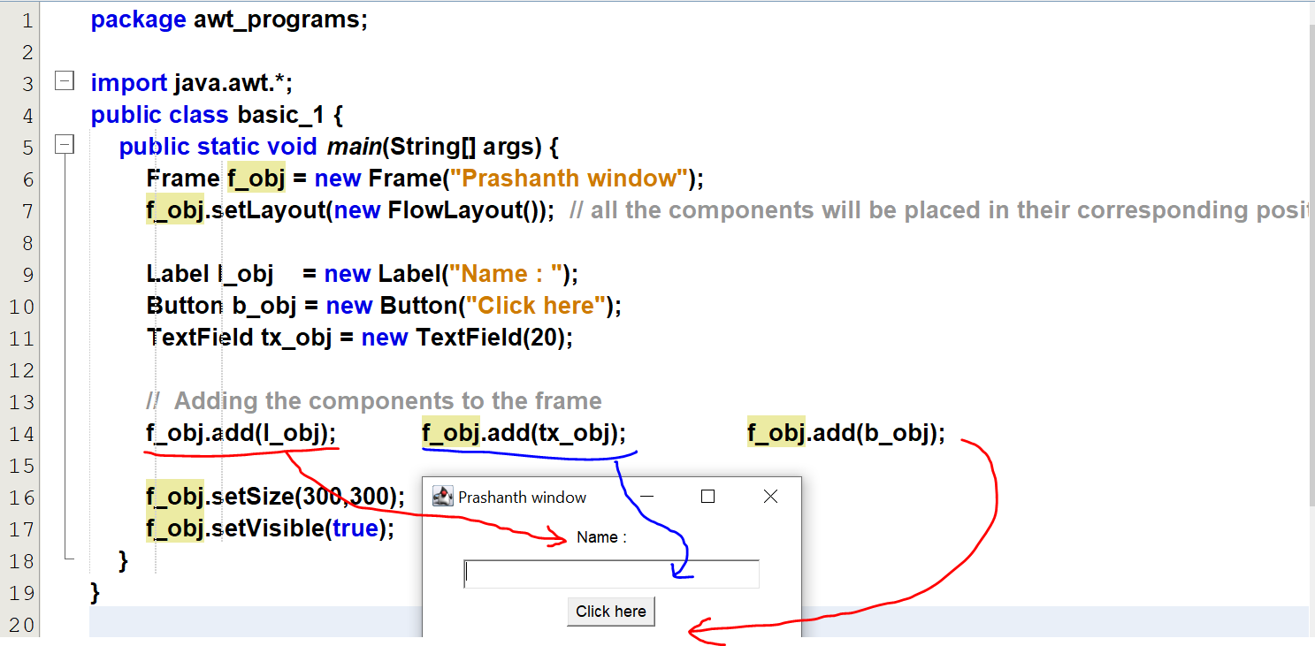

## Refer basic_2_via_class_method.java

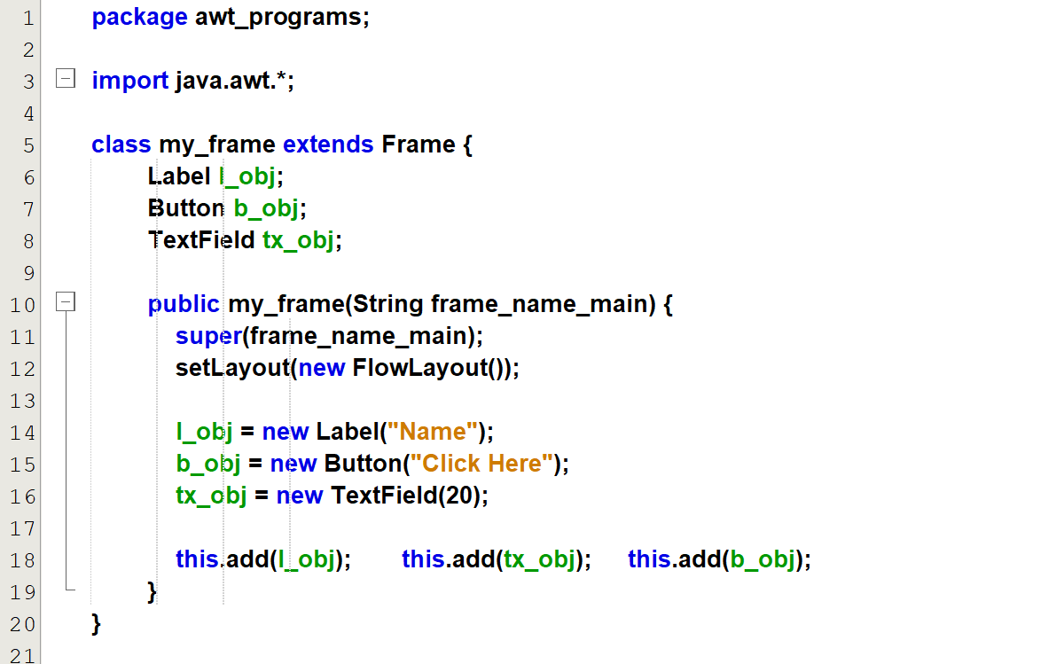  
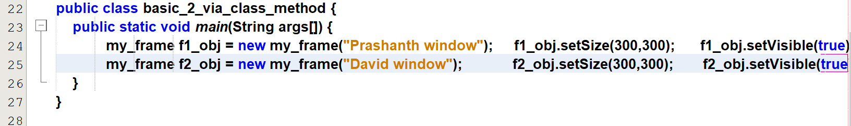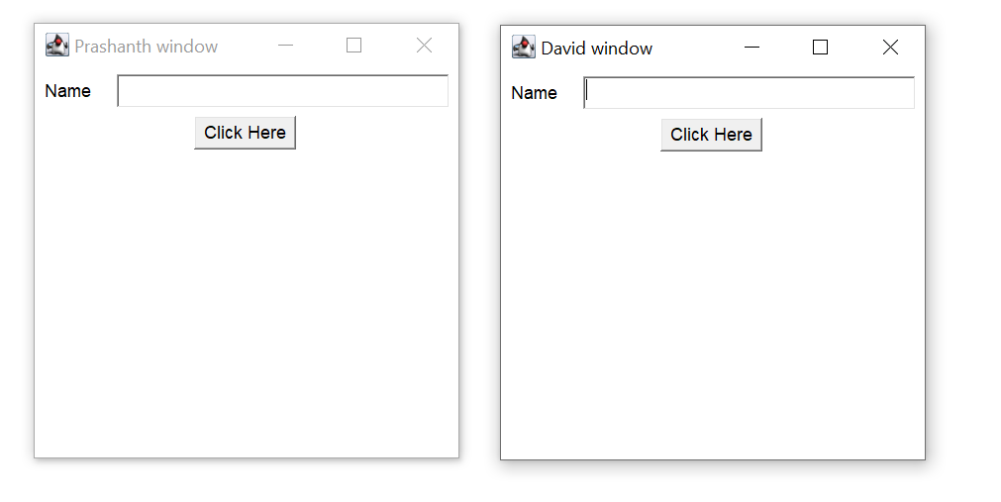

With frame class, we can multiple instances(i.e multiple windows)

## Refer basic_3_via_main_method.java

